Name of Shareholder | Address of Shareholder | Email Address | Number of Shares | Certificate Number | Date Issued

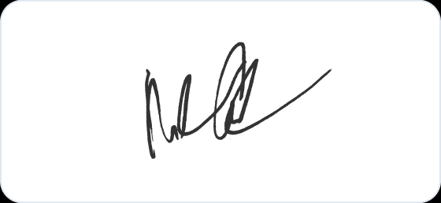
Bruce Wayne
CEO

