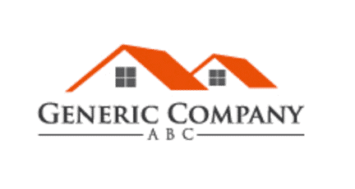
March 2, 2023

Company Legal Name – Generic Company ABC
Company’s Registered Address – 1234 Main Street, New York, NY

To whom it may concern:
Here is the ownership structure and Ultimate Beneficiary Owners of Generic Company ABC:
Ultimate Beneficiary Owner(s) | Percentage Owned
Bruce Wayne | 50%
Alfred Pennyworth | 50%

Here is the list of current Directors of Generic ABC Company
Name | Title
Richard Grayson | CFO
Selina Kyle | CTO

Kind regards,

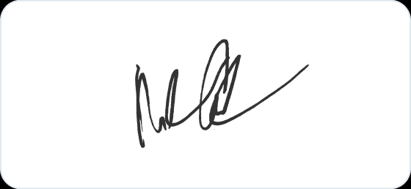

Bruce Wayne
CEO

